BY WEDNESDAY: IN DEPTH STORIES/ EXAMPLES

2/28 Mon.

Agrobot: Ray, Bryan

Da Vinci: Adam, Jerry

Kuka: Nigel

Slides [here](https://docs.google.com/presentation/d/1F_t8XufozrjQjjvvzkYqSt2taSejQQ8aW-h8p99lzmM/edit#slide=id.p)

Requirements:

1. In-depth examples / stories
2. Interactive Component

20 min total (with questions and interactions)

* 10 min presentation?
* 5 min interactive?
* 5 min questions?

Interactive Component: Kahoot? Slido? Jamboard?

Topics to cover:

* Agriculture Industry
* Abrobot: https://www.agrobot.com/
* [Agrobot E-Series Harvesting](https://www.youtube.com/watch?v=4Ody1SNv_pk)
* <https://builtin.com/robotics/farming-agricultural-robots>
* Healthcare Industry
  + [da Vinci® Surgery - How It Works](https://www.youtube.com/watch?v=QksAVT0YMEo)
  + Intuitive Surgical: https://www.intuitive.com/en-us
  + Da Vinci Machine
  + Pros & Cons of using robots in this field
  + [da Vinci Robot Stitches a Grape Back Together](https://www.youtube.com/watch?v=0XdC1HUp-rU)
* Amusement Rides Industry
* Ride vehicles
* EX: Harry Potter & the Forbidden Journey, Sum of Thrills, Knights Tournament

**Outline:**

1. Introduction

**Da Vinci Robot**

About Da Vinci Systems:

First, the term “robotic” often misleads people, which means robots don’t perform surgery. Therefore, a well-trained surgeon performs surgery with the Da Vinci system, which translates your surgeon’s hand movements at the console in real time, bending and rotating the instruments while performing the procedure.

3 parts to a Da Vinci robotic system

1. Patient Cart: Holds the instruments and sits above the patient
2. Surgeon Console: Where the surgeon sits, provides 3D visual as well as instrument controls for the surgeon
3. Vision Cart: Provides screen for visualization of the procedure, hub for power generation, image processing, and information systems

### **What happens during robotic surgery?**

* First, your surgeon makes one or more small incisions. ( only finger tip size)
* Through these incisions, your surgeon places ports (thin tubes). The robot is attached to these ports and instruments are then placed through them.
* A long thin camera (endoscope) is placed through one of the ports. The camera provides high-definition images (10 times resolution) in 3D during the surgery.
* Surgical instruments are placed through the other ports, which allows the surgeon to do the operation.
* Your surgeon controls the robotic arm while sitting at a console a few feet away from you.
* An assistant stays next to you to help the surgeon by changing the instruments when needed.

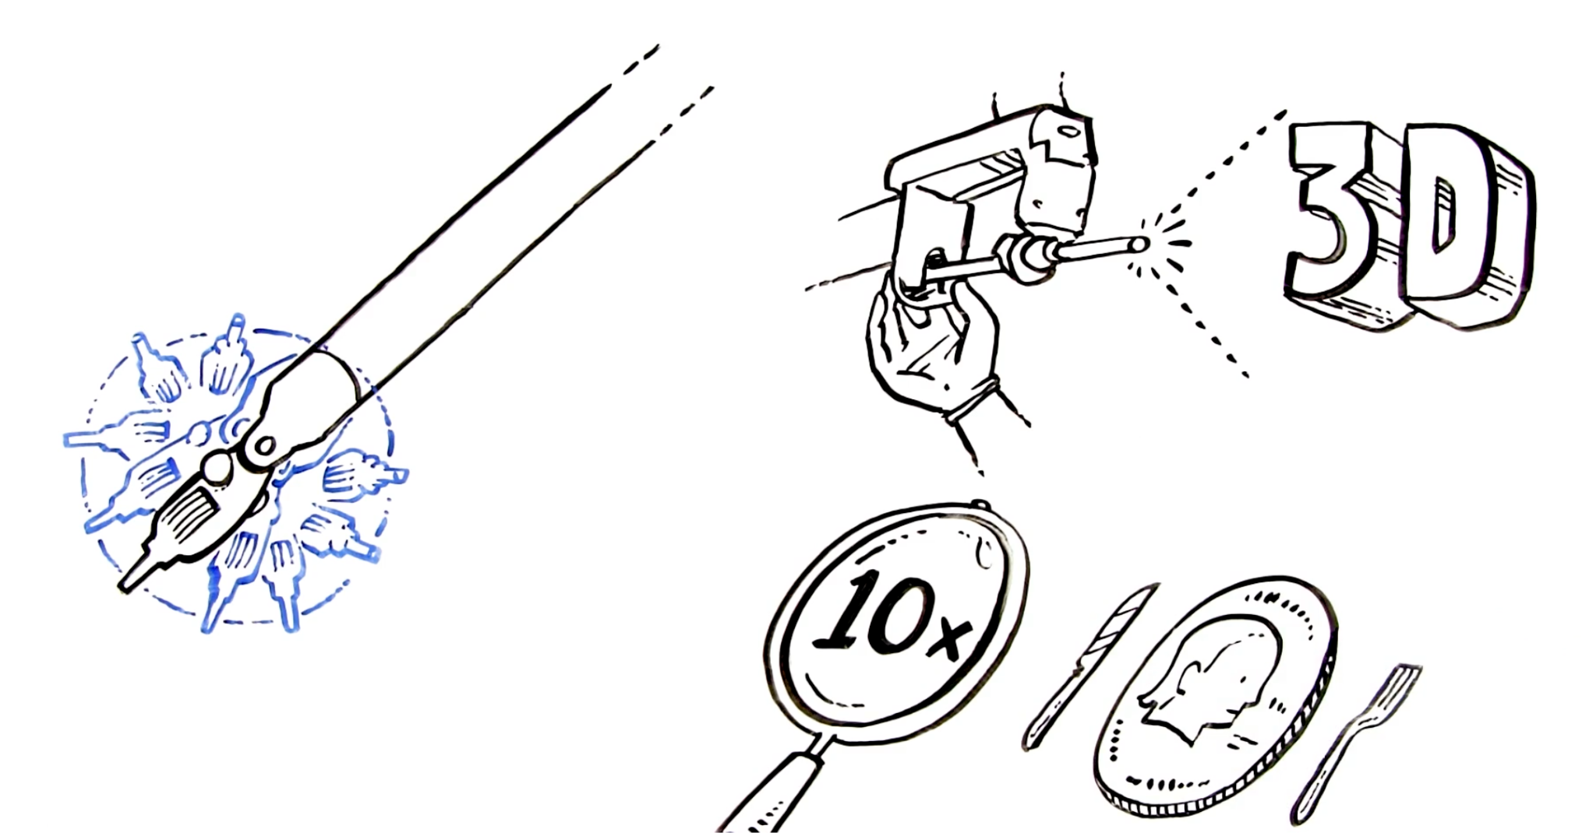

Pros:

* Minimally invasive
* Less pain
* Lower risk of complications
* Shorter hospital stays
* Less scarring
* Enhanced visualization
* More dexterity for the surgeon
* Lower fatigue for surgeon

Cons:

* No tactile feedback for the surgeon
* Higher costs
* Equipment can malfunction
* Massive learning curve on the equipment

Types of surgery performed:

* Cardiac
* Colorectal
* General
* Gynecological
* Head and Neck
* Thoracis
* Urological

Ref:

https://healthresearchfunding.org/12-pros-and-cons-of-the-da-vinci-robotic-surgery/

https://my.clevelandclinic.org/health/treatments/22178-robotic-surgery

**Agrobot**

* Strawberry video shows how it differentiates between ripe and non-ripe produce
  + Based on machine learning running in embedded systems
  + Sensors are used to analyze distances, poses, surfaces, and volumes, and create motion control systems
* E-Series
  + Up to 24 independent robotic arms that work in tandem
  + Platform is flexible — can fit any farming configuration
  + Decentralized architecture
    - This makes it easier to maintain
  + Features short-range integrated color and infrared depth sensors
    - Also has cutting-edge graphic processing
    - These features help ML accuracy for fruit ripeness
  + The robot arm never touches the fruit
    - Grips and cuts and stem
    - Then places in into field container
  + Makes sure to keep surrounding field workers safe
    - Uses LiDAR sensors to identify workers
    - Has a virtual perimeter which stops the harvester when crossed

Outline:

* Intro of Agrobot:
* Navigation: LIDAR, camera, GPS
* Gripper: scissor-like gripper, cluster picking ->applying 3D-move-to see method
* Fruit Identification: image processing based on color threshold, DL
* DL method:

1.The recognition procedure is completed by adopting a backpropagation diagnosis model and by using image pixels as inputs.

2.Supervised pattern recognition procedures such as linear discriminant analyses, K- nearest neighbors, soft independent modeling of class analogies, and multilayer feedforward artificial neural networks.

3.includes two artificial neural networks, a convolutional autoencoder (CAE), and a backpropagation neural network with a Softmax layer. A CAE involves the convergence of convolutional neural networks and an autoencoder. A traditional backpropagation neural network also plays an important role in the proposed method. To adapt the classification system to various complex scenarios, the CAE functions as a background filter, and it determines the region of interest (ROI) in an image.

* Robotic arm:
  + 3DOF:

The gripper is designed so that its workspace is strictly Cartesian, with no rotations needed, therefore, a 3‐DOF Cartesian arm is sufficient to generate this motion. The Cartesian arm is widely used due to its simplicity and low cost. Moreover, unlike the serial arm, it has no singularity problem and it has a wider working area if no rotations are required.In their development of harvesting robotics, researchers have developed a 3‐DOF Cartesian‐type arm for strawberry picking (Cui et al., 2013) as well as an algorithm to plan the movements of multiple (Zion et al., 2014), independently functioning 3‐DOF Cartesian arms for crop harvesting, mounted in backward–forward positions on the platform.

* 5DOF:

A Mitsubishi serial arm (RV‐2AJ) with 5‐DOF was employed, which was robust in terms of control and communication (Xiong et al., 2018). However, the high cost of the industrial arm is not appropriate for application in commercial farming robots, especially when multiple manipulators are required to optimize the harvesting efficiency. Moreover, in the previous system, the orientation of the 5‐DOF arm was locked to keep the gripper horizontal, which also made its working space small

**Kuka Arm Rides**

* Conventional motion simulation ride vehicles achieve 6 degrees of freedom: 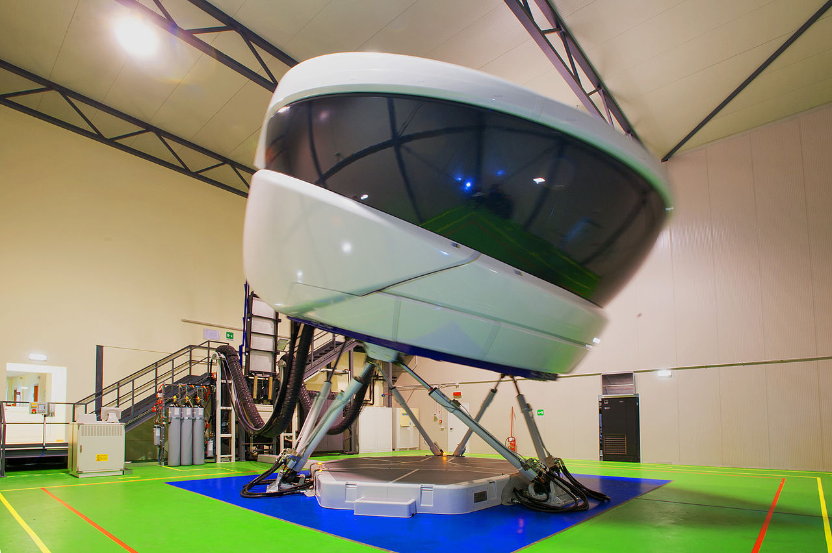
* Kuka Arm robots allow for a much larger range of motion, performing larger swoops. [ROBOCOASTERS]
* RoboCoaster system was first developed in the year 2000 by Gino De-Gol when the idea was hatched to mount a chair to the end of an industrial robotic arm
* Patent for First Gen Robocoaster:

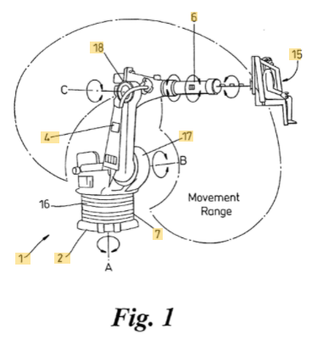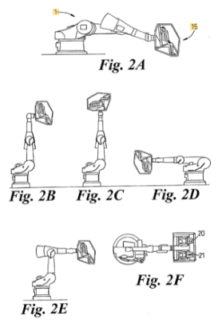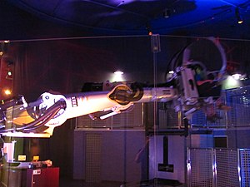

* Fixed in place.
* 2nd Gen Robocoaster was attached to a bus bar track system that allowed it to move through different show scenes. 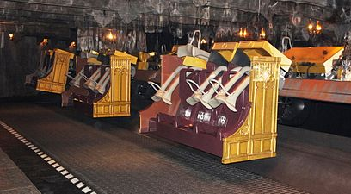
* 3rd Gen (yet to go beyond prototyping phase) involves the arm being mounted to a roller-coaster track
* [Source](https://www.coaster101.com/2014/02/27/robocoasters-101/)
* Examples: Knights Tournament at Legoland (G1 Robocoaster), Sum of All Thrills at Epcot (G1 Robocoaster, where guests could ‘design’ their own ride experience), Harry Potter & the Forbidden Journey at Universal (G2 robocoaster)
* [Harry Potter Example](https://www.youtube.com/watch?v=NT6Xj5x_51I):

→ Each “Enchanted Bench” ride vehicle (RV) is composed of a robotic arm mounted to a “transport” robot. The KUKA made robotic arms are four-axis, meaning they have four degrees of freedom in addition to the forward movement along the track. All these freedoms of motion allow the designers the ability to program the ride to replicate the sensations of flying, including swoops, dives, banked turns, stops, and fast starts.

To ensure the illusion of flight isn’t spoiled, all of this technology and mechanical components are completely hidden from view.